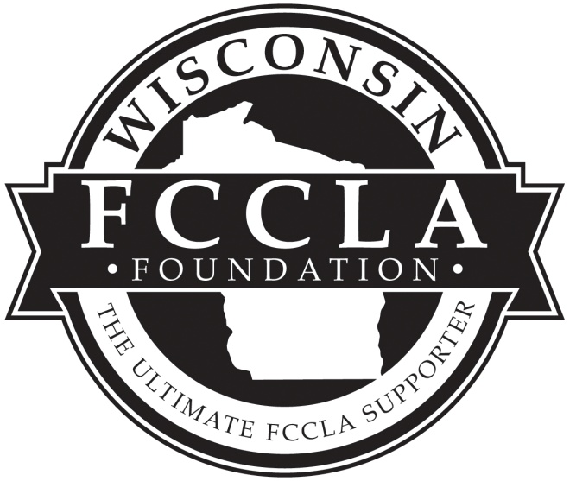

WI FCCLA Foundation Grant

2015 – 2016 Application

Rules/Guidelines
1. The project must be carried out between December 1, 2015 and May 1, 2016. The project needs to be selected from one of the national programs listed on page 2.
2. All applicants must be nationally affiliated with FCCLA 2015-2016 school year. Please include a copy of chapter 2015-2016 affiliation form with your grant application.
3. Entries must be typed on the form or copy of the form provided by the foundation.
4. Recipients will be selected based on the written grant application form. The panel of evaluators’ decision is final.
5. All applications become the property of the Foundation. Applications will be kept on file for a minimum of three year.
6. The grant application must be postmarked by November 12, 2015 (Thursday) and sent to Pat Thorsbakken, 4304 Tamara Drive, Eau Claire, WI 54701.
7. Chapter Grant recipients will be announced during the week of November
30, 2015,

Evaluation Criteria
A panel of judges will base their decision on:
1. Project Summary – 10 pts.

Relationship to an identified national program selected (5)
- Summary (5)

2. Identify Concerns, Set a Goal - 20 pts.
- Describes concerns addressed (10)
- Clarity of Goal(s) (10)

3. Form a Plan & Act – 20 pts.
- Activities & time schedule, anticipated no. of chapter members, participants, etc. (10)
- Resources to be used/budget for project, listing supplies & costs (5)
- Collaboration with other org. (5)

4. Follow Up – 20 pts.
- Evaluation method to be used (10)
- Possible impact of project (10)

5. Public Relations – 10 pts.
- Description of how project will promote better understanding of FCCLA, FCSE, & selected national program (5)
- Description of media to be used & variety (5)

6. Family and Consumer Sciences Education Skills – 10 pts.
- Project will use FCSE skills (5)
- Project will use FCCLA skills (5)

7. Overall Presentation of Grant Application – 10 pts.
- Format, conciseness, & neatness (5)
- Grammar & Spelling (5)

Information for
WI FCCLA Foundation Grants
For 2015-2016 School Year

- Up to 5 grants at $250.00 will be provided by the foundation

- The seven National Programs selected for this year chapter grant project are: 1.Student Body, 2.Facts, 3.Families First, 4. STOP the Violence, 5. Financial Fitness, 6. Career Connections and 7.Leadership Service in Action. Visit www.fcclainc.org for National Program descriptions and information. Note: Community Service is no longer a national program. Leadership Service in Action has replaced Community Service. Refer to the national Website for detailed information under Programs.

- The application form will be e-mailed to known chapter advisers on the foundation e-mail site by early Oct.

- The application form will be due (postmarked) by Thursday, November 12, 2015.

- Announcement of the chapter grant award recipients will be the week of November 30, 2015.
- Your grant notification letter will include a letter of acceptance to sign and the necessary forms to complete the grant in order to receive your funds.
- Requirements to obtain the grant monies: 1. Share your project at the 2016 State FCCLA Leadership Conference, with a 3-fold display. 2. Complete a 3 page form upon the completion of grant, due May 15, 2016. 3. Grant funds will be distributed after the state conference.
- STAR Event Participation: Your project could be the basis for many STAR Events as an individual or team event. Some examples of STAR Events that could be used include: Illustrated Talk, Focus on Children, National Program in Action, Chapter Service Project Display, and Life Event Planning.
- National Awards Available: Your chapter is encouraged to enter your national program chapter project for a national program award. The application form is a bit different for each national program. Our grant chapter project follows somewhat the national program application and contains most of the elements needed to complete the national program for awards. First place award is $1,000, and forms are found at www.fcclainc.org
- This grant application follows the FCCLA Planning Process.
- A chapter may submit 2 chapter grant applications. If there are funds still available after all acceptable grant applications are funded, then a Chapter’s second grant application will be considered for funding. Advisers, if you submit two grant applications, please rank as first choice and second choice.

Wisconsin FCCLA Foundation Grant Application

Chapter name___________________________ School name ________________________________

School address______________________________________________________________________

City __________________________________ Zip_____________________

School phone ___________________________ School fax _________________________________

Adviser’s name_________________________ Adviser’s e-mail address_________________________

Principal’s name ________________________District Administrator name ______________________

District Administrator’s address____________________________________________________

Chapter information (please check all that apply) ____ High school level chapter
____ Occupational members ____ Comprehensive members ____ Middle school level chapter
____ Intra-curricular chapter ____ Out-of class chapter ____ Jr/Sr HS combined chapter

Number of affiliated members _____________________________________________________

Number of chapter members who will likely participate in this project ___________________

Population of community____________________ Total enrollment of school ______________

We understand that by submitting this form, if selected as one of the grant recipients, our chapter must have at least one member and adviser in attendance at the WI FCCLA SLC.

All information submitted is correct to the best of our knowledge. Please sign below.

Chapter representative(s): ________________________________________________________

_____________________________________________________________________________

Chapter Adviser: _________________________________________ Date ________________

Principal: _______________________________________________Date _______________
WI FCCLA Foundation Grant Project Application Form

Project Summary (10 points) This application follows the FCCLA Planning Process. (Identify Concerns, Set a Goal, Form A Plan, Act, and Follow-Up)

National Programs selected for a chapter project: Choose a national program that meets your chapter concern from the following: Financial Fitness, Career Connections. FACTS, Families First, Stop the Violence, Student Body and Leadership in Action.

Fill in this section (A, B, C,) after you have completed the planning of your project Numbers 1 through 8.

- Title of Chapter Project:_________________________________________

- National Project Selected_________________________________________

C. Briefly summarize your project and what your chapter plans to accomplish. (10 points)

(Note: Questions 1, 2, 3, 4, 5, relate to the FCCLA Planning Process)
1. A. Identify Concerns (10 points)

Questions to think about in regard to your concerns: What concerns exist in your community?

Is it a local or societal concern or both? Why is this concern an issue? What population is being targeted for this concern? Do these concerns relate to a national FCCLA program or programs? What data can support these concerns?

Once you have identified your concerns, it is time to write your goal
2 B. Set Your Project’s Goal 10 points
__________________________________________________________________________________________________________________________________________________________________________
_____________________________________________________________________________________
______________________________________________________________________________________________________________________________________________________________________________________________________________________________________________________________

Check your written goal/s for these components: 1.Who is going to do it? 2. What is going to happen? 3. When will it happen? 4. Where will the activity/ project take place? 5. How will it be done?

When your written goal is completed, then answer these questions: 1.Is your goal specific? (Does it define exactly what will be done?) Is this goal achievable? (Can your members accomplish the goal?)
Is this project Time Specific? (Can your goal be completed in this time frame?) If you answer these questions with a “Yes”, then your goal is ready to implement. Otherwise make changes as needed.

3. Form a Plan & Act: Activities, Resources, and Budget (20 points) (Budget form is on the last page of application)

- Briefly describe the major activities and time line you plan to use to carry out the project. Include anticipated number of chapter members to be involved, number of participants in events, number of people to be reached with information, etc.

(Note: Below is a form to follow; however, it not necessary to present your information for A. in this format. You may use any format that includes the following categories.)

Briefly Describe Major Activities | Identify Time Line | Number of Chapter members involved | Estimate number of participants/audience members to be involved

3. Form a Plan & Act: (Continued from page 5)

- List resources to be used.

- Include budget for project: list items to be purchased, uses and cost.(see budget page on the last page of this form P.8)

- List/describe collaborations/activities with other organizations including school and community.

- Follow Up: Evaluation and Impact of Project (20 points)

A. Briefly describe the evaluation METHOD you will use to measure project results.
How will you get specific measurements/numbers to show you how well you are achieving your goal and or the progress of your project? Examples of methods to use: pre and post surveys, observations of behavior, test of knowledge, evaluation forms, and reflection forms.

B. Describe the impact on attitudes and behaviors you hope your project will have on individuals and/or groups involved. What changes in attitude will you hope the project will have on its members and peers?

5. Public Relations (10 points)

Describe how this project will promote a better understanding of FCCLA, Family and Consumer Sciences Education and the selected FCCLA National Program. List specific ways that this project will inform others about us (School, community, and peers)

List the media you plan to use, such as radio, television/access cable, bulletin board, Web sites, newspapers, etc.

6. Family and Consumer Sciences Education Skills (10 points)

Describe how members will use their Family and Consumer Science Education skills during the project. Listed below are examples of these skills.

Informational Skills: (What information do you need to know to carry out your project?)

Example: one may need to know age appropriate activities for elementary children for a child development national program project.

Research skills: (What sources will you use?)

Evaluation skills: (How will you evaluate the progress of your project?)

Intellectual skills: (How will you use these skills with your project? List at least one idea for each intellectual skill listed below. )

- Decision making skills,

Questioning skills,

Organizational skills,

Communication skills,

Consumer skills,

7. Presentation (10 points)
Up to 10 points may be awarded for the overall presentation of this application, including format, conciseness, grammar, spelling, and neatness.
BUDGET FORM TO USE FOR WI FCCLA FOUNDATION GRANT APPLICATION (Refer to question 3 on application form)

DIRECTIONS: In preparing your budget, think of all the resources needed for your project. Try to find resources that may be no cost to your project.

Determine type and amount of resources needed for your project. Some examples of items/resources you may want for your project:

RESOURCES: Books, Videos, DVD, Games, Speakers, Other technical devices
SUPPLIES: Paper, Markers, Pens, Film, Computer cartridges, Binders, Folders, Food
Products, Prizes, Gift for Speaker, Other

Keep all of your sales receipts and invoices as this is necessary to obtain your grant money at the end of the project. Without your slips, we cannot disburse money. As a foundation, we cannot reimburse tax money charged on purchases.

BUDGET PROPSAL FOR 2015-2016 CHAPTER GRANT

Category(resources & supplies) Proposed Amount Amount Spent

Mail application form to: Pat Thorsbakken 4304 Tamara Drive,
Eau Claire, Wi 54701 by November 12, 2015

